  
  
  
  
  
  
  
  
Entity and Individual – Display OWS results more than 2700 chars

International Registries, Inc.

**Document Control Information**

**Document Information**

|  |  |
| --- | --- |
| Document Identification | <Insert document ID, if applicable> |
| **Document Name** | Entity and Individual – Display OWS results more than 2700 chars.docx |
|  |  |
| **Project Name** | Oracle Watchlist Screening (OWS) |
| **Client** | IRI |
| **Document Author** | Yusuf Rajkotwala |
| **Document Version** | 0.1 |
| **Document Status** |  |
| **Date Released** |  |

**Document Edit History**

|  |  |  |  |
| --- | --- | --- | --- |
| Version | Date | Additions/Modifications | Prepared/Revised by |
| 0.1 | Mar, 2022 | Created Draft version | Yusuf Rajkotwala |
|  |  |  |  |
|  |  |  |  |
|  |  |  |  |

**Document Review/Approval History**

|  |  |  |  |
| --- | --- | --- | --- |
| Date | Name | Organization/Title | Comments |
|  |  |  |  |
|  |  |  |  |
|  |  |  |  |
|  |  |  |  |
|  |  |  |  |

**Distribution of Final Document**

The following people are designated recipients of the final version of this document:

|  |  |
| --- | --- |
| Name | Organization/Title |
|  |  |
|  |  |
|  |  |
|  |  |
|  |  |

Table of Contents

1. Project Overview 4

2. Purpose 4

3. Scope 4

4. Business Requirements 5

4.1. Analysis 5

4.2. Requirement 6

5. Solution 7

# Project Overview

International Registries, Inc. (IRI) is using Oracle Watch List Screening Solution. Oracle has implemented the Watchlist Management and Watchlist Screening (3 bucket solution) Solutions. Inspirage is engaged with IRI for development and support of OWS solution and has developed SAN Watchlist Screening (1 Bucket Solution).

For a few fields received in the Refinitiv World-check data file, the length is more than 2700 characters, whereas OWS truncates any text longer than 2700 characters, by default. This document describes the requirement around this scenario and the proposed solution.

# Purpose

This document captures requirement for resolving the issue when Refinitiv data field has more than 2700 chars.

# Scope

The following fields for SAN Watchlist Screening Individual / Entity project are in scope of this document

* Additional Information
* External Sources
* Cached External Sources

# Business Requirements

By default, the length of OWS data fields in the result set is 2700 characters. Any data longer than 2700 characters is truncated while displaying the results to the user. This results in loss of potentially useful information that business could leverage to determine the alert outcomes.

The requirement is to be able to view the entire result string or provide an alert saying that OWS is not returning the entire text and that the user should review the data from world-check.com site directly.

## Analysis

There below three fields in OWS result set are identified as having some data longer than 2700 characters:

|  |  |  |
| --- | --- | --- |
| Sr No | OWS Data Field | EBS Data Field |
| 1 | Additional Information | Summary |
| 2 | External Sources | Links |
| 3 | Cached External Sources | Cached Links |

The data visible in EBS is highlighted below (2700 characters):

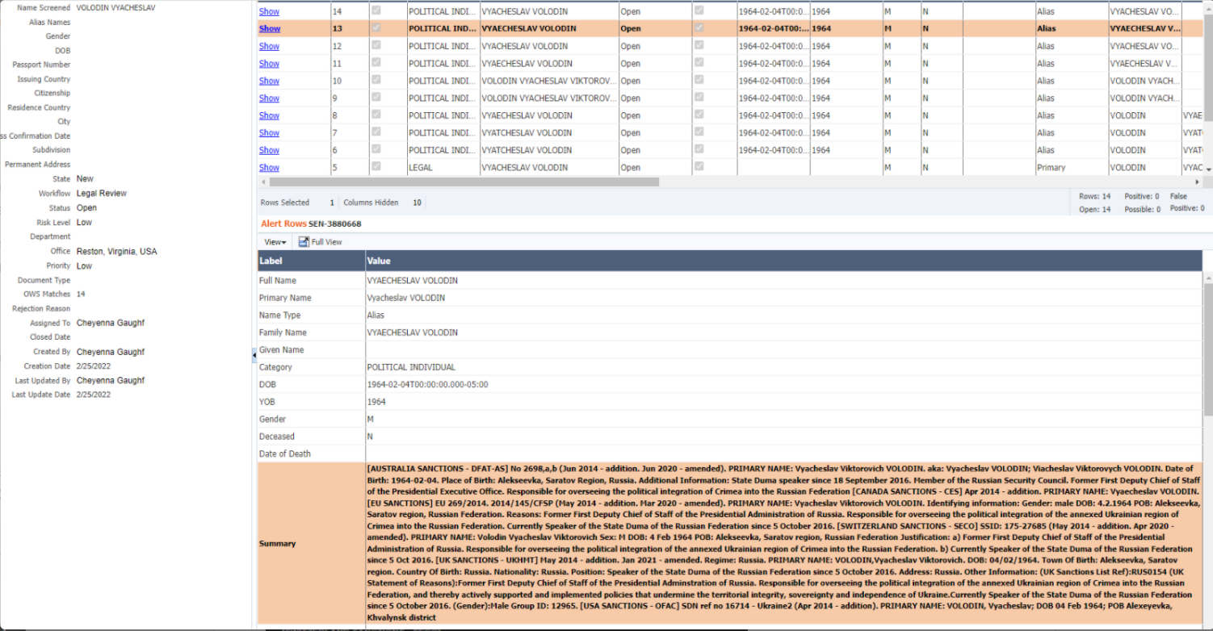

The same data visible on world-check.com site is shown below. The text over 2700 characters that are truncated in OWS is highlighted in the screenshot.

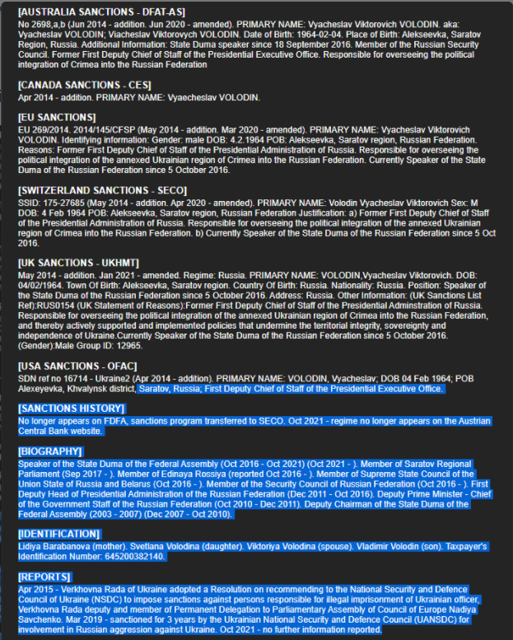

## Requirement

The first requirement is to increase the data string length in OWS to 4000 characters. This is the maximum value allowed by OWS for Oracle database.

The next requirement is to display the actual values, if the length of the Additional Information, External Sources and Cached External Sources data is up to 4000 chars and –

1. If the length of Additional Information/Summary column is more than 4000 chars, then display the below static text instead of the data value:

***"Alert: Summary details are not complete please login to*** [***https://www.world-***](https://www.world-) ***check.com/frontend/login/ with the current UID in order to proceed"***

1. If the length of External Sources/Links column is more than 4000 chars, then display the below static text instead of the data value:

***"Alert: Link details are not complete please login to*** [***https://www.world-***](https://www.world-) ***check.com/frontend/login/ with the current UID in order to proceed"***

1. If the length of Cached External Sources/Cached Links column is more than 4000 chars, then display the below static text instead of the data value:

***"Alert: Cached Link details are not complete please login to*** [***https://www.world-***](https://www.world-) ***check.com/frontend/login/ with the current UID in order to proceed"***

# Example/Solution

1. **Existing Behavior -** The below results for Individual shows that the data in the fields External Sources, Cached External Sources and Additional Information are truncated in OWS and do not show the entire data.

**Individual - Existing behavior**

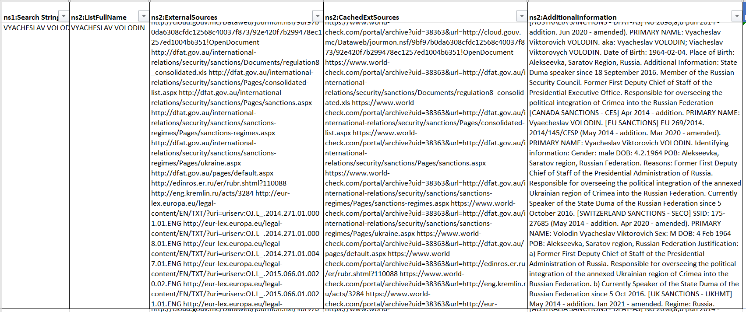

**Proposed behavior** - The table below shows the proposed results for the three fields. If the data length is more than 4000 characters, then replace it with the static string.

**Individual – Proposed behavior**

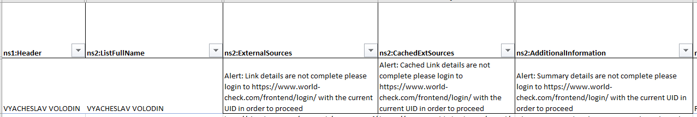

1. **Existing behavior** - The result below for Entity shows that the data in the fields External Sources, Cached External Sources and Additional Information are truncated in OWS and do not show the entire data.

**Entity - Existing behavior**

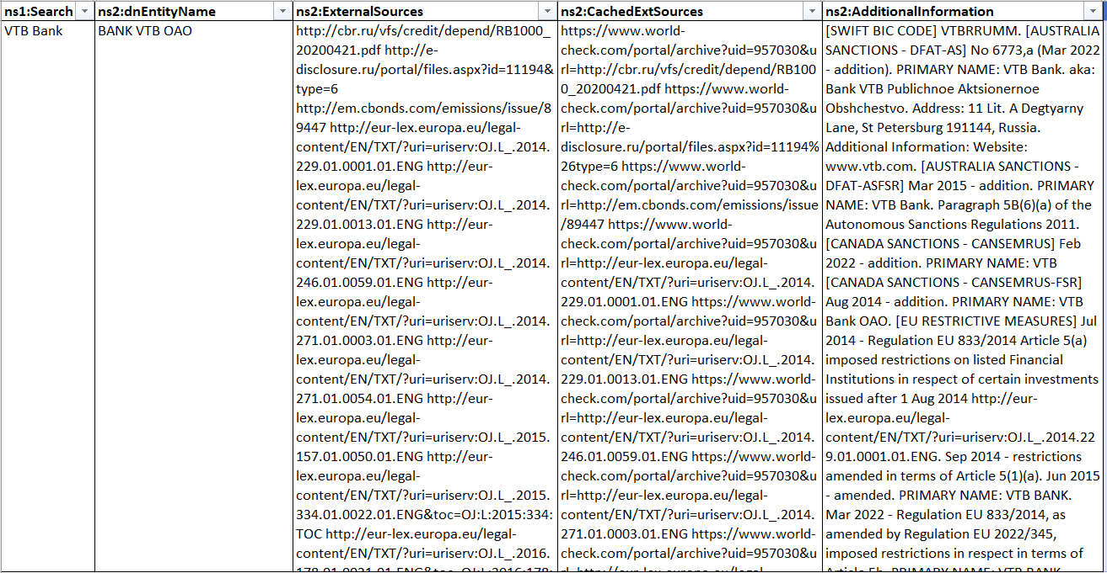

**Proposed behavior** - The table below shows the proposed results for the three fields. If the data length is more than 4000 characters, then replace it with the static string.

**Entity – Proposed behavior**

